**Bandit Level 8**

“The password for the next level is stored in the file **data.txt** next to the word **millionth”**

**I ran Ls:**



**I then used grep to find the name in that file:**



**Copying password for server 8**

**cvX2JJa4CFALtqS87jk27qwqGhBM9plV**

**Logging into server 8:**

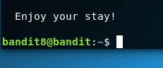

**Success!**